Rafael Urano Frajndlich

Universidade de São Paulo

**Lima, João Filgueiras – Lelé (1932-)**

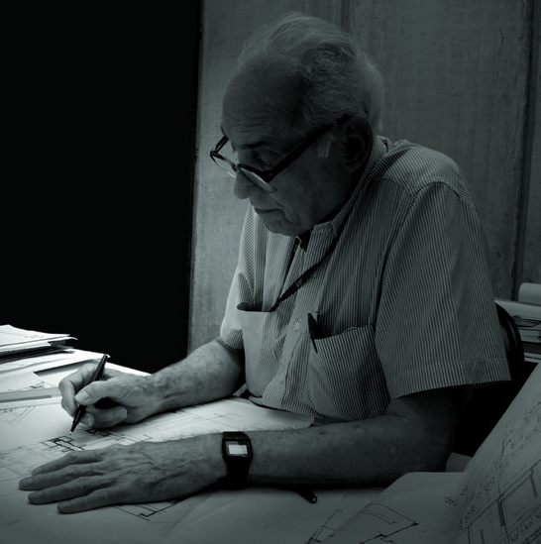

João Filgueiras Lima – Lelé

*divulgation*.

João “Lelé” Filgueiras Lima is a public architect. Since his formative years in the construction sites of Brasília (1960) until today, his most remarkable works were made in public branches. This aspect of his career led him to make a very plastic approach relying always on economic building strategies, often developing new techniques and industrial materials.

Lelé’s interest in industrial building parts led him to design pieces of his own, used in some early public works, such as the Taguatinga Hospital (1965) and the Secretariats of Bahia Administration Center (1973). Lelé had a breakthrough when he designed hospitals for the Sarah Kubitschek Foundation. In Brasília’s Hospital for Diseases of The Motor Organs (1980), he managed in an integrated approach, to fill the normative standards for a rehabilitation facility, to keep the tight budget and to soften the very hot enviroment of Brasília. A lag between the stories allow all recovering rooms to access a well shaded green terrace. Structure and cladding are made of prefabricated reinforced concrete, articulated with one-story high Virendell beams.

Brasilia’s Hospital became a reference, giving Lelé authority to give new inputs. In his next experiences, the structures would be lighter and the building would be faster. Steel would be used in structures and in ceiling structures, like ventilation sheds. For cladding, Lelé worked with a technique of prefabricated reinforced mortar. Reinforced mortar is an economic and light material, easy to make and easy to handle in building sites.

This combination of steel and prefab reinforced mortar is Lelé’s favorite choice up to his nowadays projects. They allowed Lelé to make the most of his expression through industrialized materials. The Sarah Kubitschek Locomotor Apparatus Hospital (1988) in Salvador has such a plastic appeal that at first glance it hardly resembles an industrialized construction. Heat was once again an important issue to be solved, softened with a sucession of gardens and natural ventilation systems, like steel sheds and a ground cooling system. The reinforced mortar walls had patterns designed by Brazilian artist Athos Bulcão.

Furthermore, Lelé designed Sarah hospitals in almost all capitals of Northern Brazil, even making a factory just to build his special pieces, the Technology Center of Rede Sarah (1992). There he perfected his techniques, which the results can be seen in subsequent works such as Rede Sarah’s hospitals in Belo Horizonte (1993), a new unit built in Brasilia (1995) and in Rio de Janeiro (2009).

Lelé’s recent works include housing design for middle sized cities of Brazil (2011), as part of a National initiative of the government. He is broadly recognized by his very peculiar work as an architect capable of giving an unique forms to his projects through a modular, component based system of constructive pieces.

**List of works**

1962 Housing units for professors of the University of Brasília, Brasília, Brazil

1965 Taguatinga Hospital, Taguatinga, Brazil

1973 Secretariats of Bahia Administration Center, Salvador, Brazil

1980 Industrialized schools, Salvador, Brazil

Hospital for Diseases of The Motor Organs, Brasília, Brazil

1984 Abadiânia Factory, Goiania, Brazil

1988 Sarah Kubitschek Locomotor Apparatus Hospital, Salvador, Brazil

1992 Technology Center of Rede Sarah Kubitschek, Salvador, Brazil

2009 Sarah Kubitschek Hospital, Rio de Janeiro, Brazil

2011 Housing units system for brazilian government

**References and further reading**

Latorraca, G. (2000), *João Filgueiras Lima, Lelé,* Lisbon and São Paulo: Editorial Blau and Instituto Lina Bo e P. M. Bardi.

Banda, M. (2003), ‘Hospital Sarah Lago Norte’, *Abitare*, 430: 116-121.

**Visual material**

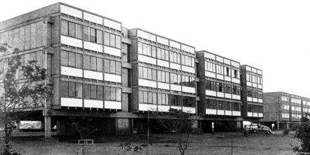

Housing units for professors of the University of Brasília, 1962

citrus.uspnet.usp.br

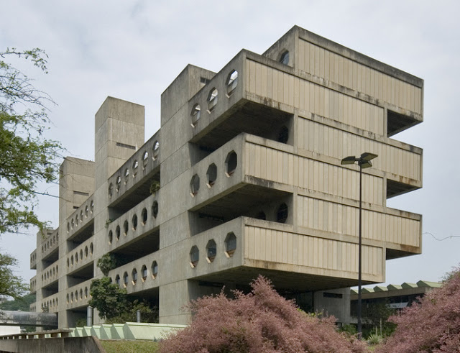

Hospital for Diseases of The Motor Organs, 1980

4bp.blogspot.com

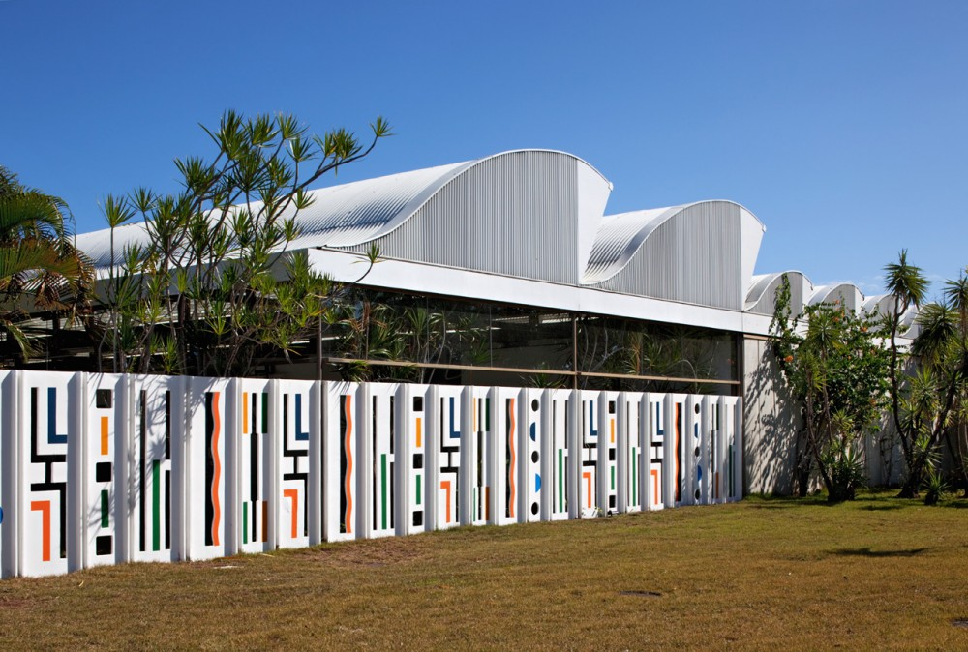

Sarah Kubitschek Locomotor Apparatus Hospital, 1988

comover-arq.blogspot.com

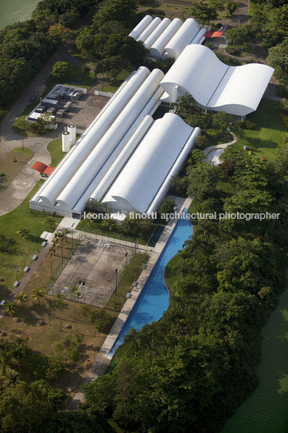

Rio de Janeiro Hospital, 2009

copyright: Leonardo Finotti

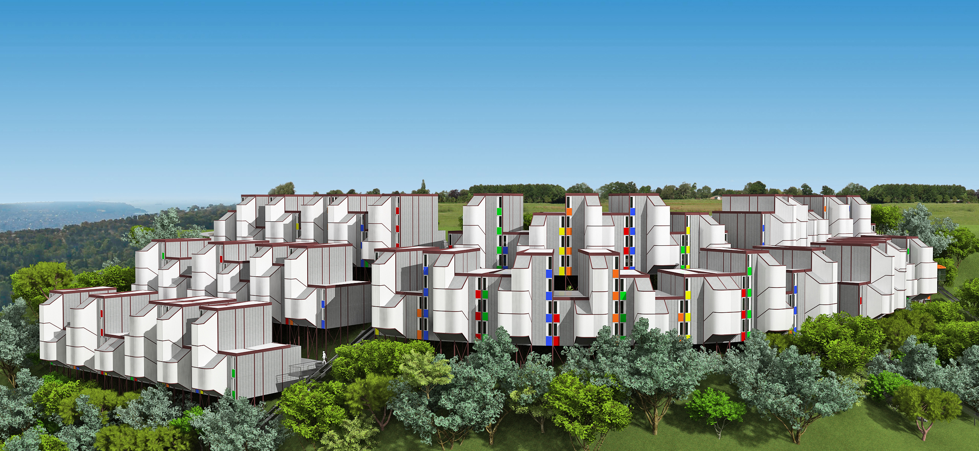

Housing units system for brazilian government, 2011

copyright: João Filgueiras Lima